Code1:

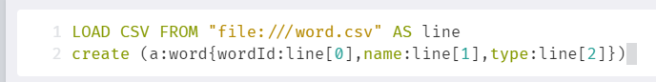

Output1:

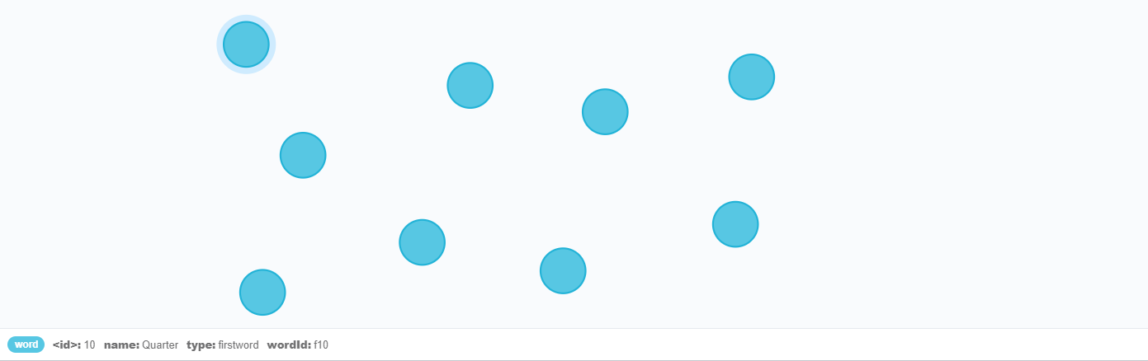

Code2:



Output2:

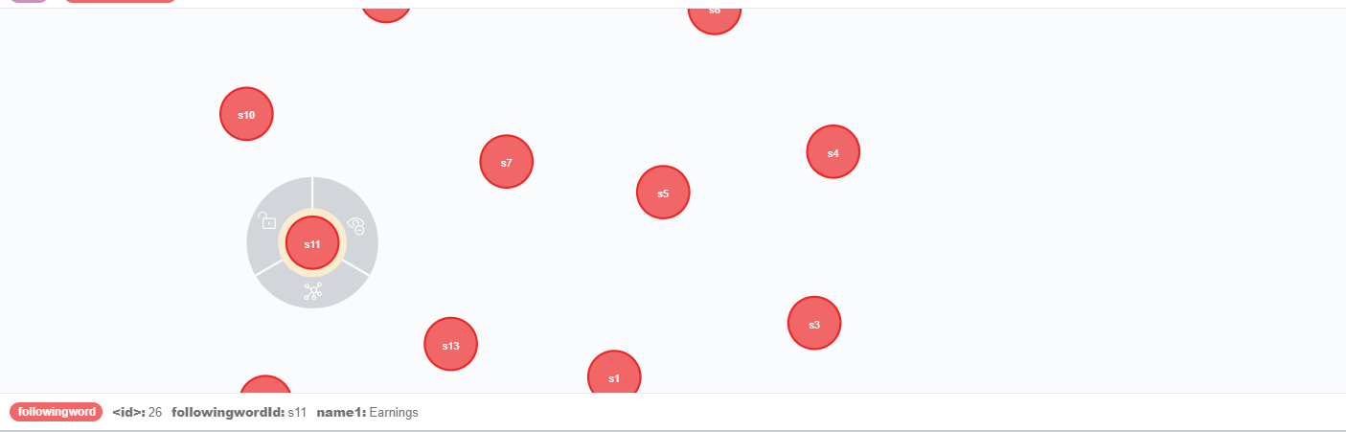

Code3:

’

Output3:

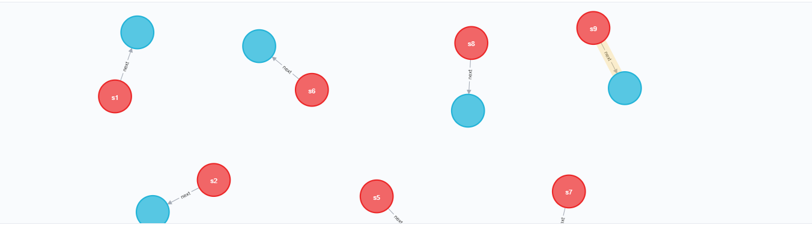

e.g.

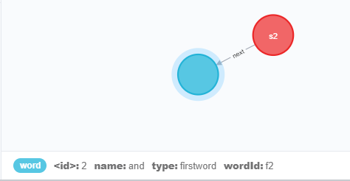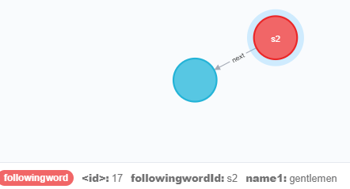

This pair shows the word “and ” is followed by “gentlemen” in the text.